For invalid tracking number:

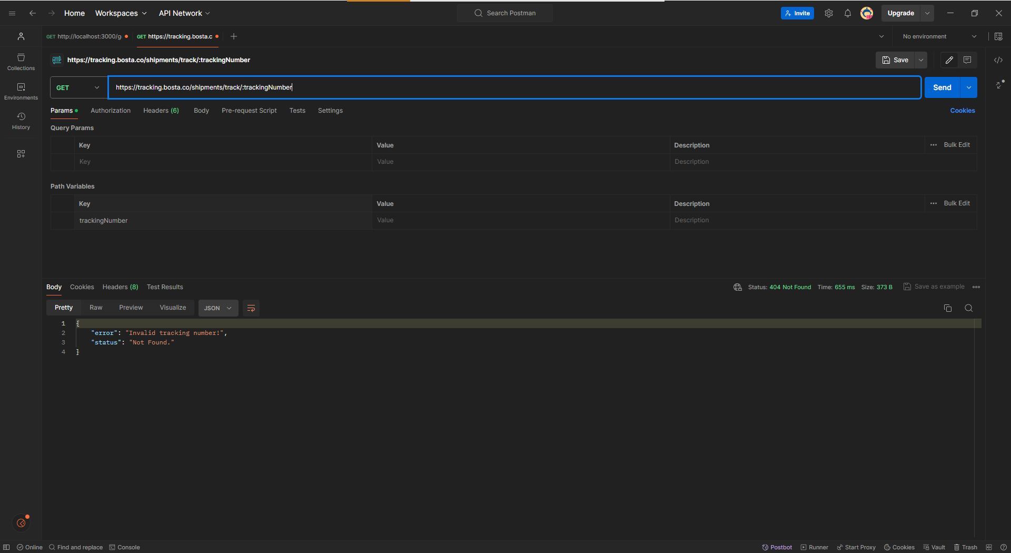

Valid numbers return just as expected:   
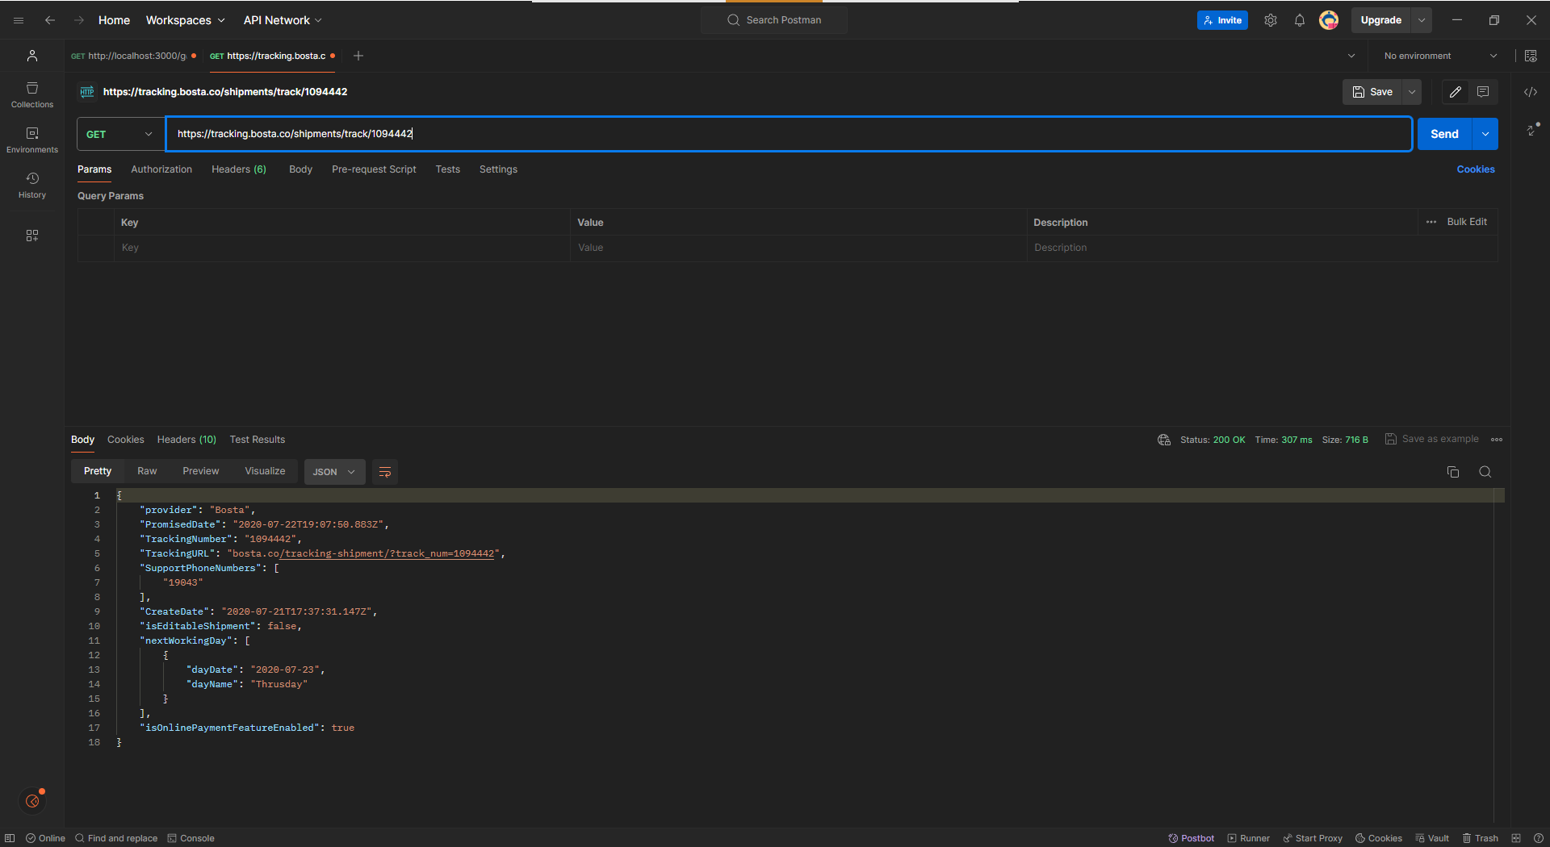

Valid Tracking Number - Successful Response

Input: trackingNumber = 6636234

Expected Result:

Status Code: 200

Response contains CurrentStatus, TrackingNumber, TrackingURL, SupportPhoneNumbers, CreateDate, and TransitEvents.

Valid Tracking Number - Response Format JSON

Header: Accept = application/json

Input: trackingNumber = 7234258

Expected Result:

Status Code: 200

Response is in JSON format.

Valid Tracking Number - Response Format XML

Header: Accept = application/xml

Input: trackingNumber = 9442984

Expected Result:

Status Code: 200

Response is in XML format.

Valid Tracking Number - Default Content-Type

Header: Content-Type = application/json

Input: trackingNumber = 1094442

Expected Result:

Status Code: 200

Response processed successfully with the default content type.

Valid Tracking Number - Specific X-Requested-By Header

Header: X-Requested-By = Landmark

Input: trackingNumber = 6636234

Expected Result:

Status Code: 200

Response includes valid TrackingURL, SupportPhoneNumbers, etc.

Invalid Tracking Number - Nonexistent Delivery

Input: trackingNumber = 9999999

Expected Result:

Status Code: 404

Error message indicating the tracking number does not exist.

Invalid Tracking Number - Malformed Input

Input: trackingNumber = "abc123"

Expected Result:

Status Code: 400 (Bad Request, if supported) or 404

Error message indicating invalid input format.

Empty Tracking Number

Input: trackingNumber = ""

Expected Result:

Status Code: 404 or 400

Error message indicating the tracking number is missing or invalid.

Unsupported Accept Header

Header: Accept = text/html

Input: trackingNumber = 7234258

Expected Result:

Status Code: 406 (Not Acceptable)

Error message indicating unsupported response format.

Unsupported Content-Type Header

Header: Content-Type = text/plain

Input: trackingNumber = 6636234

Expected Result:

Status Code: 415 (Unsupported Media Type)

Error message indicating unsupported request format.